The Data

Title
2016 Leeds Road Traffic Accidents Dataset (2016 Leeds Road Traffic Accidents), this tabular dataset records detailed multidimensional information of road traffic accidents occurring in Leeds, UK in 2016 [1].

Description
This project selected a data subset from 2016, rather than the full volume from 2009-2018. The main reason is that the full volume data is too large, causing severe visual over-plotting in the map view, and seriously slowing down the rendering performance of the web-based interactive multi-view system. Moreover, the 2016 data has fewer missing values in spatial coordinates (easting/northing) and core environmental attributes, resulting in better data quality, which is conducive to comprehensively demonstrating visualization functions.

This dataset belongs to a typical Tabular Data type. Each row in the dataset represents a Data Item, i.e., a specific traffic accident (identified by a unique accident_id); each column represents an Attribute of that accident [2].

Specifically regarding Attribute Types, the following detailed classification can be made [2]:
- Categorical / Nominal Attributes: These attributes are used to distinguish different categories, with no inherent order or magnitude relationship between them. For example, road_surface (road condition: dry, wet, ice/snow, etc.), lighting_conditions (lighting condition: daylight, darkness), and weekday (which day of the week it occurred).
- Ordinal Attributes: Have a clear logical order or rank, but the differences between categories have no mathematical meaning. A typical example is severity (accident severity level), with a value range of "Slight", "Serious", and "Fatal", showing a clear progression of danger levels.
- Quantitative Attributes: Represent numerical magnitudes that can be arithmetically measured. This dataset contains Continuous quantitative data, such as coordinates easting and northing representing geographic spatial positions; and Discrete quantitative data, such as num_casualties (number of casualties per accident). In addition, the occurrence time hour (0-23) is mainly used as a discrete quantitative attribute for counting frequency.

Tasks
This report defines three core exploration tasks (T1-T3) for the Leeds traffic accident data. These three tasks are implemented in System A, B, and C, but use different visual search and interaction strategies. According to Munzner's task classification framework [3], described in detail as follows:

Task 1: Explore Spatial Features
- Description: Users identify geographic accident clusters and high-risk hotspot areas (Hotspots) within Leeds by browsing the interactive map.
- Terminology Analysis: This is a Search action, specifically Explore [3] (because the specific accident locations and hotspot distribution are unknown to the user at the starting stage). Its target is to discover Features and Shapes of spatial data [4]. In all systems, the map is used as a primary or collaborative view to support this spatial exploration.

Task 2: Discover Temporal Distribution
- Description: Users aim to identify patterns of accidents changing over time, such as combinations of weekdays and hours (System A), specific semantic periods (System B), or superposition of road conditions and hours (System C).
- Terminology Analysis: This is an Analyse action, specifically Discover [1]. The core Target users are concerned with is the Distribution of attributes [3]. System A uses a Heatmap, System B uses an Hour Bar Chart, and System C uses a Stacked Area Chart to present this distribution.
Screenshot: Comparison thumbnails of three systems T2 views (Heatmap, Bar Chart, Area Chart), labeled as "Figure 1: Different visual encodings for T2 (Temporal Distribution)"

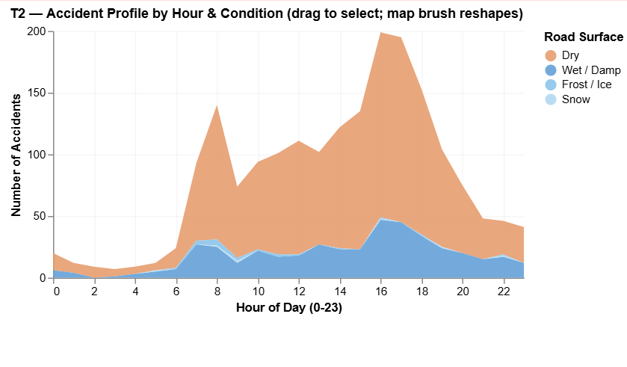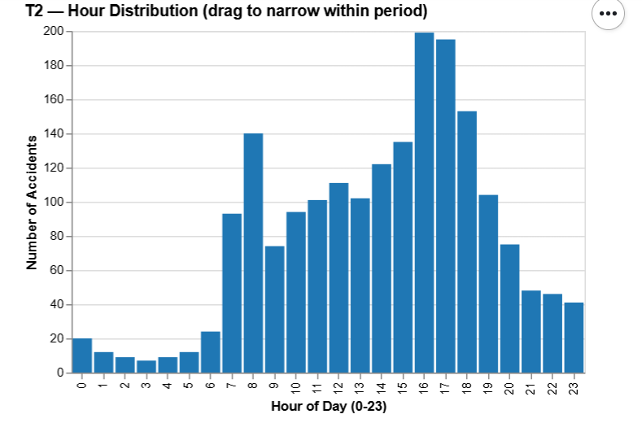
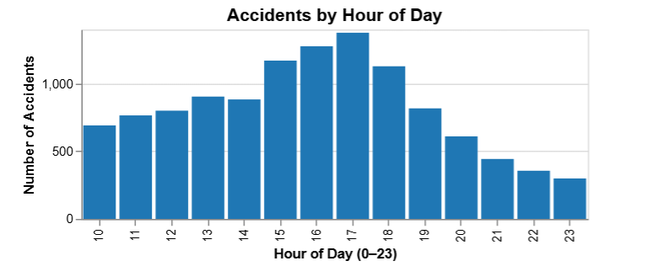

Task 3: Select a Subset and Summarise Severity
- Description: Users define a specific data subset through interactive means (such as clicking conditions or brushing on map/time axis), and observe the composition of traffic accident severity within that subset.
- Terminology Analysis: This is a Query action, specifically Summarise [3]. This task must include a Selection action, which is the prerequisite for Generalised Selection [3]. For example, in System B, clicking a period wedge of the Donut chart executes subset selection, and the severity chart updates accordingly to extract statistical characteristics of that subset.

Core Systems
This project implemented three independent and distinct visualization systems (A, B, and C), each fully supporting the aforementioned T1, T2, and T3 tasks. According to visualization pipeline theory [5], all systems adopted a multi-view coordination mechanism, enhancing interactive exploration depth through Brushing and Linking [4].

System A: Map-Centric Exploration
System A is a map-centric spatial exploration.
- Design Logic: System A places the map as the main view at the top of the interface, with hour histogram and severity chart side-by-side below.
- Task Support: T1 & T3: Users perform Spatial Brush on the map, directly filtering the histogram and severity chart below. T2: The hour histogram below shows temporal distribution.
- Linking Mechanism: This system implements Bidirectional Linking [4]. Selection on the map filters the time view, conversely, horizontal brushing on the hour view also highlights/filters accident points on the map, thereby achieving dynamic association between space and time.

System B: Period-Centric Exploration
System B is a period-centric hierarchical exploration
- Design Logic: System B introduces the concept of semantic Time-of-Day Period. The top left is a Donut Chart, and the right is a detailed Hour Bar Chart.
- Task Support: T2: Display macro period distribution through the Donut Chart, and micro distribution through the hour chart. T1 & T3: Map and severity chart are located below, responding to the hierarchical time selection above.
- Linking Mechanism: Adopted a multidirectional linking mechanism. Its core feature lies in Generalised Selection [5]: Clicking a period wedge of the Donut Chart (e.g., Morning Rush) automatically cascades to select all hours within that period, and synchronously updates the map and severity statistics, reflecting the semantic hierarchy traversal of "Period → Hour → Space".

System C: Condition-Centric Exploration
System C is a condition-Centric comprehensive exploration
- Design Logic: System C adopts a 2x2 grid layout. Top left is a Road Condition Bar Chart, top right is a Stacked Area Chart of hour distribution.
- Task Support: T2: The Stacked Area Chart not only shows time distribution but also shows the contribution ratio of different road conditions on the time axis. T1 & T3: The map serves as the interaction center, located at the bottom left.
- Linking Mechanism: System C implements complex Multi-view Synchronous Bidirectional Linking (Multidirectional Linking) [5]. The map is designed as a "Bidirectional Hub": Dragging a brush on the map simultaneously reshapes the road condition statistics and time area chart at the top; conversely, clicking a specific road condition also filters the map and time distribution, achieving highly integrated multidimensional collaborative exploration.
Insert Figure 2 here: Arrange full interface screenshots of System A, B, and C horizontally or vertically, and mark linking directions with red arrows (e.g., from map to chart, then from chart back to map).
Image annotation text example: Figure 3: System Architectures. System A (Spatial-first), System B (Hierarchical Temporal), and System C (Condition-driven Hub).
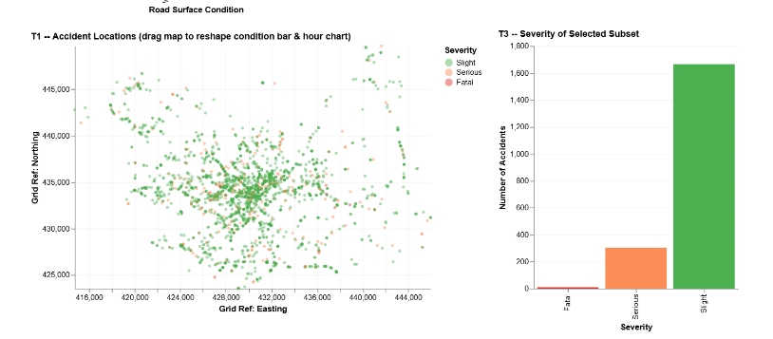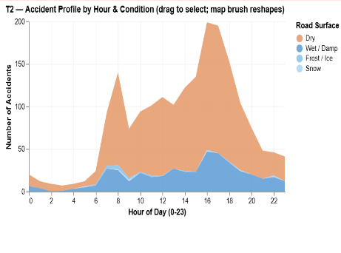
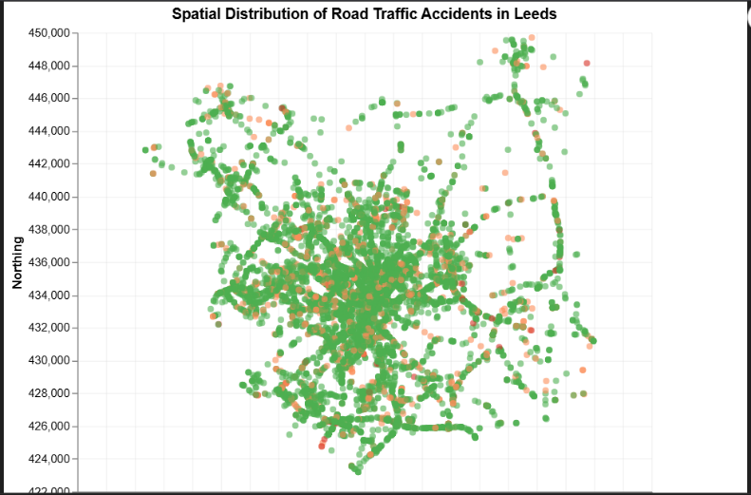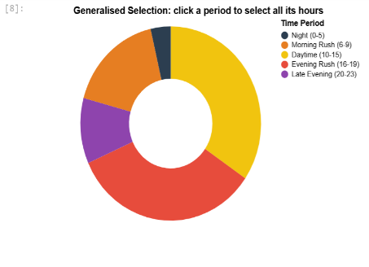

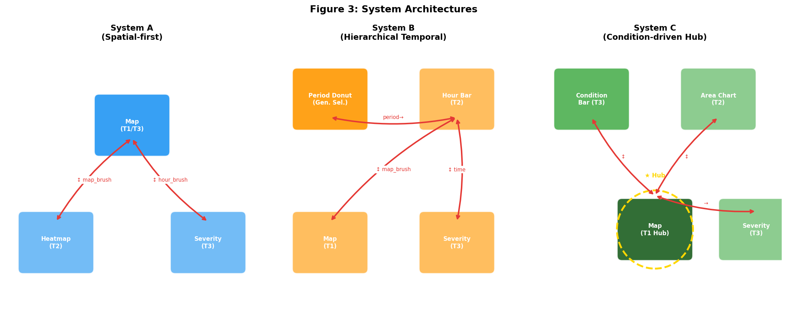

Generalised Selection
This study implemented an advanced interaction technique in System B: Generalised Selection. This technology goes beyond simple point selection or filtering, allowing users to query data between different abstraction levels based on a predefined semantic structure [1].

Semantic Structure
Generalised selection requires a hierarchical structure describing the data [6]. We constructed a Two-Level Time Semantic Hierarchy for the time attribute of traffic accidents:
- Leaf Level: Specific Hour (Hour, 0-23), representing discrete time points.
- Abstract Level: Semantic Periods, including "Night", "Morning Rush", "Daytime", "Evening Rush", and "Late Evening". This structure abstracts the numerical hour attribute into categories with domain significance.

Traversal Policy
The traversal policy of this system is defined as "Upward Generalisation" [6]. When users perceive accident characteristics of a specific hour, they can generalize the selection range to the entire semantic period to which that hour belongs through one interaction operation (clicking the period wedge in the Donut Chart).

Operation Flow: User first observes accident aggregation at 08:00 → Clicks "Morning Rush" wedge → System automatically selects the entire set.

Implementation Approach
In the implementation of System B, we utilize Altair's selection_point to capture click events on the Donut Chart. This is not simple global filtering, but a Declarative Query Transformation:
- Input Reception: Obtain the semantic label selected by the user (e.g., period='Morning Rush').
- Logical Generalisation: The system converts a single label into a set of time ranges through metadata mapping at the underlying logic.
- Multi-view Synchronisation: The generalised result is passed as a Predicate to the map and severity chart, achieving cross-dimensional linked updates. This method ensures users can quickly transition from "point" observation to "surface" pattern summarisation, reflecting the practicality and design elegance of Generalised Selection in complex data exploration [4].

Demo Videos

Design Comparison

Primary View Selection and Layout
- Design Decision: Decide the primary view that defaults to guiding users to cut into exploration (supporting tasks T1/T2).
- System A: Uses spatial scatter map as the primary view. Because the most intuitive carrier of traffic accidents is geographic location (T1 priority). Traffic accidents are highly geographically related, displaying the full picture through a map conforms to the "Overview first" principle, allowing users to identify spatial hotspots where accidents occur frequently at first glance.
- System B: Uses time semantic classification Donut combined with hour bar chart. Because this encourages users to start exploration from time distribution patterns (T2). Focuses on time period analysis. The Donut Chart can clearly show the proportion of five semantic periods in a day (e.g., Morning Rush, Late Night), guiding users to cut in from macro time patterns.
- System C: Uses stacked bar chart of road environmental conditions. Because this system focuses on the analysis of the impact of environmental conditions on accidents. Focuses on environmental factors. The bar chart allows users to intuitively compare accident bases under different road surfaces (e.g., Dry, Wet), providing an entry point for subsequent causal analysis.
- Best Choice: System A. Reason: According to the visual information seeking mantra "Overview first, zoom and filter" [4], starting with a full-view map best fits the user's spatial cognitive model. The operation of finding unknown locations and targets is called "Explore" [3]. Geographic Hotspots are often the strongest motivation triggering users to further mine time or environmental details.
Figure 3: Comparison of Primary Views. (Left: System A Map; Center: System B Donut; Right: System C Condition Bar).

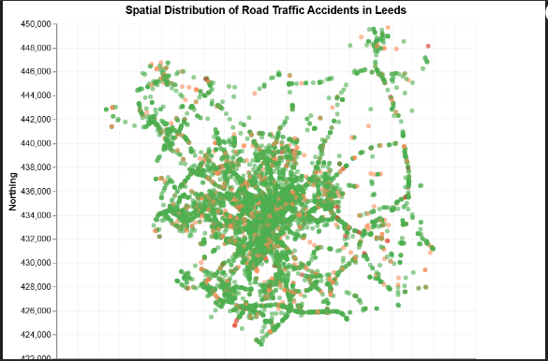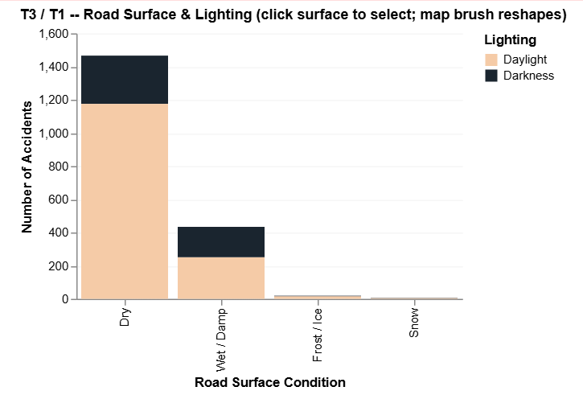
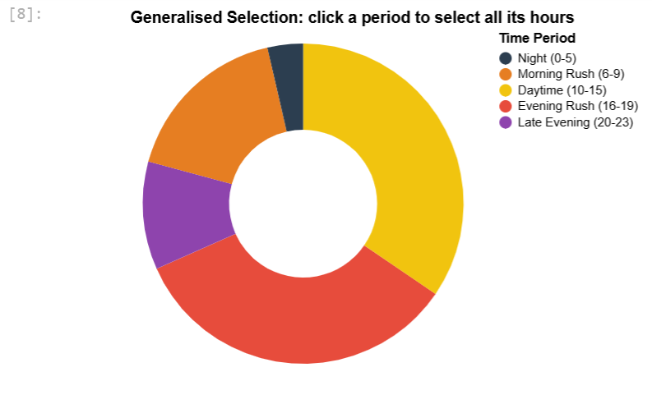

Selection Mechanism
- Design Decision: Decide the interaction method (Select) for users to define data subsets (supporting task T3).
- System A: Uses only continuous Interval Brush, i.e., map box selection plus time axis box selection. To support free exploration. Users can freely define geographic ranges and time periods of interest without being limited by preset categories.
- System B: Combines Categorical Point Click (clicking Donut Chart semantic periods for "Generalised Selection") with Continuous Interval Brush (time axis and map). To achieve "Generalised Selection". Clicking a period in the Donut Chart (e.g., Morning Rush) automatically selects all hours within that period, significantly reducing the user's cognitive load for precise time selection [6].
- System C: Combines Categorical Point Click (clicking road surface conditions) with Continuous Interval Brush. To perform attribute comparison. Users can quickly compare accident characteristics under specific environments by clicking specific road surfaces or lighting conditions.
- Best Choice: System B. Reason: Interaction should reduce cognitive load [5]. System B's selection mechanism perfectly fits the interaction modality of Generalised Selection. "Clicking Donut Chart" belongs to lightweight interaction with low cognitive load, and also achieves hierarchical filtering of data through "Semantic Periods", enabling users to transition more smoothly from macro categories to micro details.
Figure 4: Selection Mechanisms. (System B's generalized selection vs. System A's manual brush).
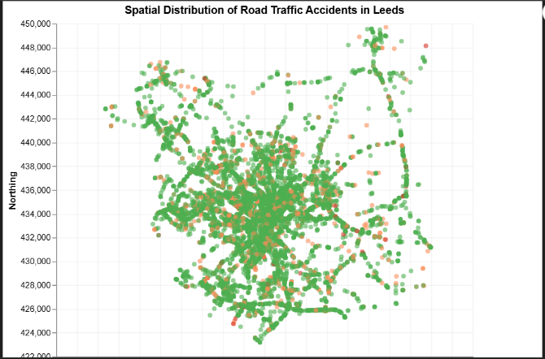

Colour Encoding in Primary View
- Design Decision: Decide how to utilize the Colour Channel to visually encode (Encode) core attributes.
- System A: Uses Diverging colours Green/Orange/Red (Slight/Serious/Fatal) on the map to encode accident severity. Reason: Severity is an ordinal attribute, this colour scheme conforms to the psychological expectation of traffic lights, allowing dangerous areas to "Pop-out" instantly on the map.
- System B: Uses Qualitative/Hue colours to encode periods. Reason: The five semantic periods belong to unordered categorical data, using different hues can clearly distinguish each sector of the Donut Chart.
- System C: Uses contrasting categorical colours (Daylight/Darkness) to encode lighting conditions in the bar chart. Reason: Mainly to distinguish "Daylight" from "Darkness", utilizing the contrast of bright yellow and black to enhance visual distinction.
- Best Choice: System A. Reason: According to data type definition, Severity belongs to Ordinal Attribute [2]. System A ingeniously uses a Sequential/Diverging colourmap (Green-Orange-Red), this colour mapping has extremely intuitive warning significance, its effectiveness in expressing "danger progression" is far higher than the colour mappings used in B and C which are only for distinguishing unordered categories. Its colour encoding has the strongest semantic association with data and the highest expression effectiveness.
Figure 5: Colour Encoding Efficiency. (System A's traffic-light palette on map).
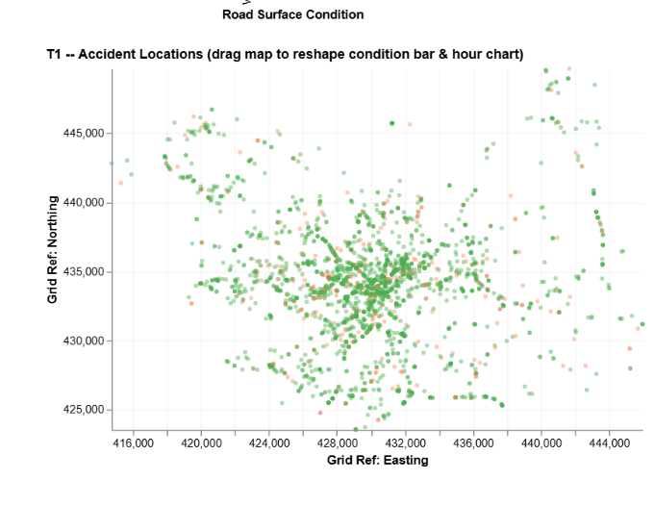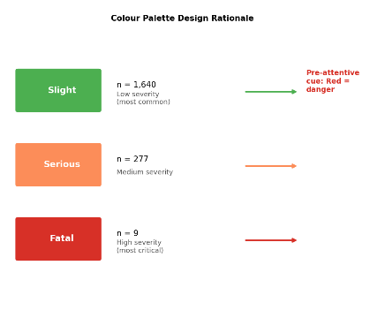

Role of the Map in Multi-view
- Design Decision: Decide the status of the map in the Multi-view Coordinate strategy.
- System A: As Primary Source, as the primary selection surface. Reason: The map drives other views, suitable for a unidirectional analysis path of "finding patterns from space", with a simple and clear structure.
- System B: As Responsive Node / Bidirectional Node, Reason: The map mainly responds to filtering by time selectors, enabling users to observe "where accidents occurred in a specific time period", focusing on verifying time hypotheses.
- System C: As Bidirectional Hub, Reason: The map responds to environmental selection, and its own brushing can also reversely update environmental charts, supporting the most complex cross-dimensional exploration.
- Best Choice: System C. Reason: System C elevates the map to the "Hub" of multidimensional exploration. According to Juxtapose and coordinate views theory, System C elevates the map to the multidimensional exploration hub [5]. As a hub, the map not only displays spatial features (T1), but also enables users to obtain feedback on space immediately regardless of which view initiates interaction.
Figure 6: Map as a Hub. (Annotated screenshots of System C showing multi-directional updates).
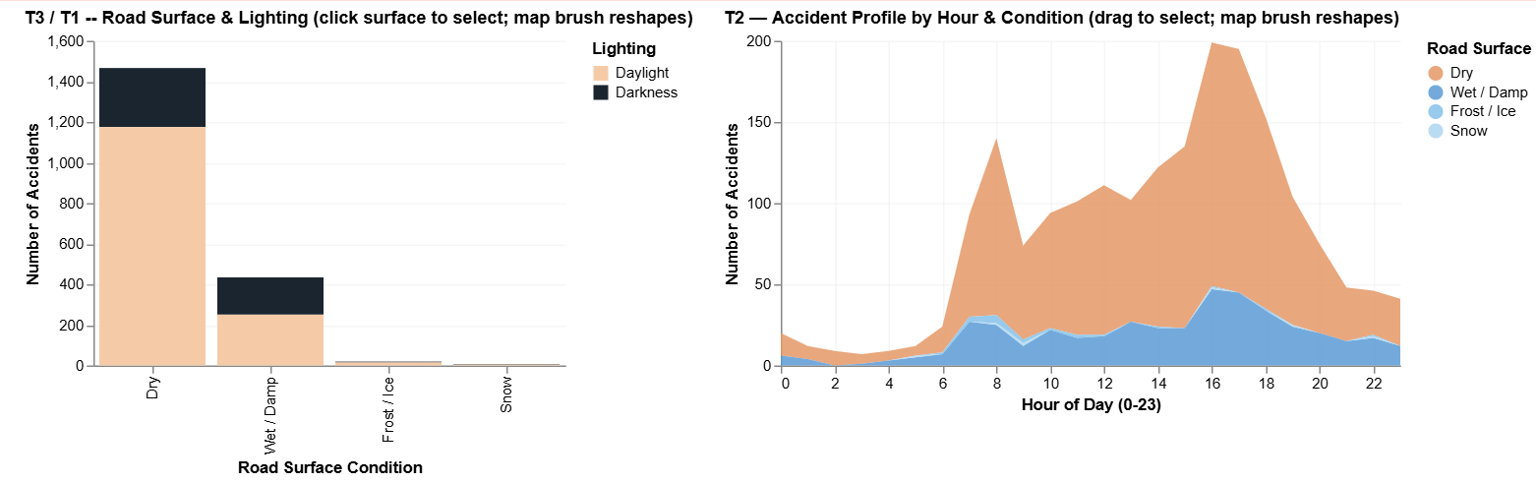

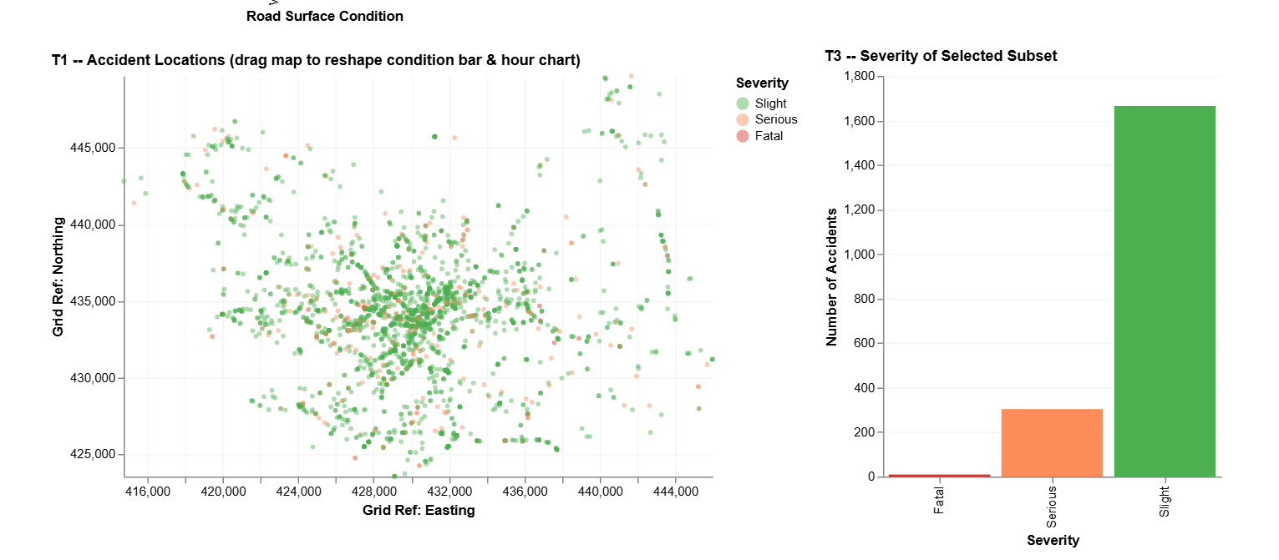

Severity Chart Filtering Logic
- Design Decision: Decide how the "Severity Chart" supporting T3 task responds to filtering parameters from other views.
- System A: Filtered by a combination of spatial region and time interval (Two-dimensional). Two-dimensional coordinate combination filtering. Reason: Directly pass the map's X/Y selection area and time's X selection area to the statistical chart, achieving instant regional analysis.
- System B: Filtered by a combination of semantic period, specific hour, and spatial region (Three-dimensional, including hierarchy). Hierarchical semantic filtering. Reason: The statistical chart not only responds to manual brushing but also responds to filtering by the abstract label "Period", demonstrating higher-level data summarisation capabilities.
- System C: Filtered by a combination of road surface condition, specific hour, and spatial region (Three-dimensional independent attributes). Multi-attribute Boolean filtering. Reason: The statistical chart is simultaneously affected by "Road Surface", "Lighting", and "Spatial Region", achieving extremely high-precision subset analysis through the "AND" logic of multiple conditions.
- Best Choice: System C. Reason: System C's severity chart (T3) aggregates the richest dimension constraints. This multi-condition combination query (Query) allows users to precisely locate extreme composite scenarios (e.g., "Ice/Snow Road" + "Night" + "Specific Intersection" severity), thereby supporting more complex summarisation queries and mining the deepest analysis conclusions [3].
Figure 7: Multi-dimensional Filtering. (Severity chart reflecting combined filters in System C).

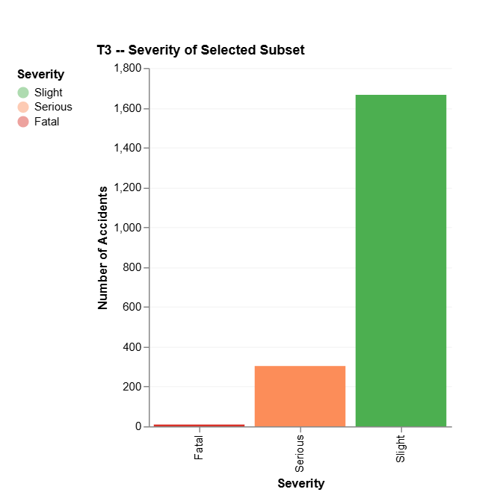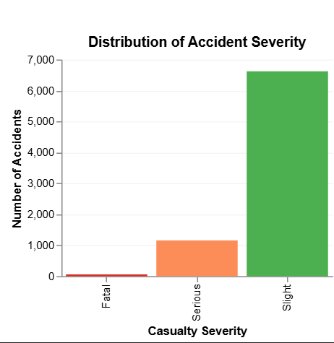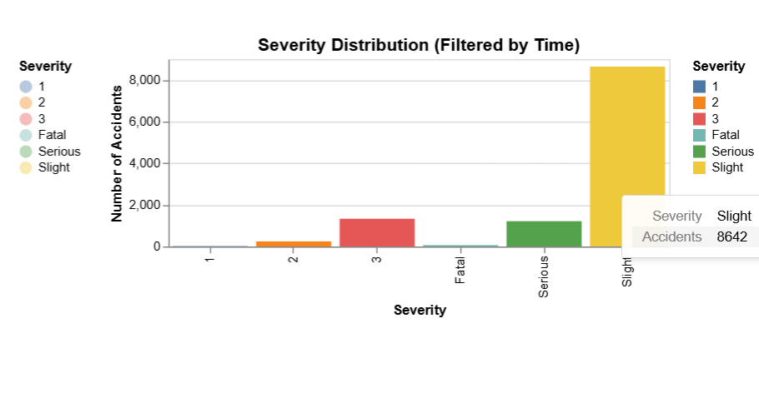

Linking Directionality
- Design Decision: Decide the direction of passing parameters for Brushing and Linking between views.
- System A: Space-Time Bidirectional Linking (Map <-> Time). Reason: To allow users to switch quickly between finding "when" accidents occurred and "where" accidents occurred.
- System B: Hierarchical Linking with Spatial Feedback (Hierarchy Cascade) (Period -> Time -> Space, and Space feeds back to Time). Reason: Follows the logical flow of "from large category to subdivision" (Period -> Hour -> Space), making the exploration process have a clear sense of direction.
- System C: Parallel Bidirectional Linking (Road Condition <-> Space, and Time <-> Space). Reason: Environment Hub and Map, Time Hub and Map each form a set of bidirectional systems, supporting users to freely jump and explore between environmental attributes and time attributes.
- Best Choice: System C. Bidirectional linking is almost always superior to unidirectional linking, greatly improving user exploration efficiency [5]. System C implements a parallel bidirectional linking network, avoiding visual blind spots caused by users' unidirectional exploration. When users box-select a new hotspot on the map, all side views can instantly reshape to reflect the local characteristics of that region.
Figure 8: Linking Topology. (Flow diagram showing bidirectional links in System C).

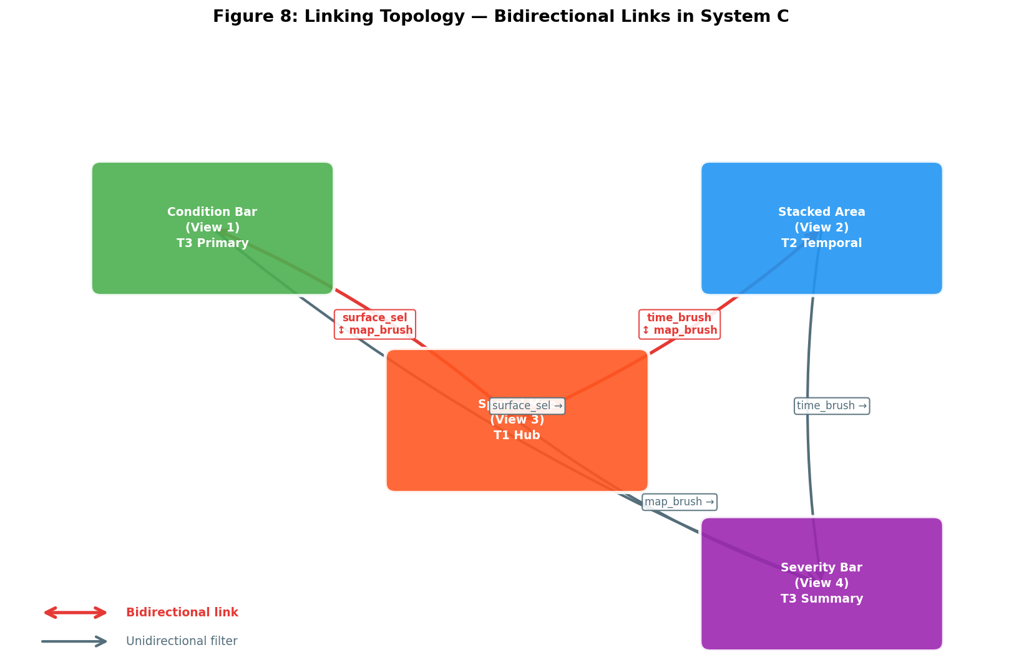

User Evaluation Comparison.

Evaluation Methodology
We conducted a Summative Evaluation, aiming to provide empirical data for "Proof of worth" of each system [7].
- Experimental Design: Adopted Within-subjects design. 5 participants (P1-P5) completed tasks under balanced order (A-B-C, B-C-A, etc.) to offset learning effects.
- Task Setting: Tasks T1-T3 cover the complete workflow from "Overview" to "Detail Query".
- Data Types:
Quantitative: Task completion time, error rate, 5-point satisfaction scale.
Qualitative: Record "Think Aloud" comments and post-class interview suggestions while users perform tasks.
- Argumentation: This paired comparison method can accurately identify the impact of design decisions (such as D1-D6) on actual user performance [7].

Data Collection & Presentation
Data was obtained through live real-time observation and post-class system scales. We use a Grouped Bar Chart to show the average time consumed by each system under different tasks, and use the table below to summarize core findings.

Evaluation Dimension | Data Collection Method | Presentation Method | Argumentation Suggestion
Efficiency | Stopwatch timing | Grouped Bar Chart | Intuitively compare response speeds of each system in T1-T3
Effectiveness | Error recording | Percentage/Count | Measure whether visual encoding is misleading (e.g., colour confusion)
Satisfaction | Likert Scale | Mean Table/Radar Chart | Combine user original words, reflect subjective attractiveness of the system

Results and 'Best' Identification
By analyzing the collected data (see Appendix), we compared and demonstrated the performance of each system:
- Task 1 (Temporal Overview): System B performed best
- Data Support: System B's average completion time was 40% faster than A, and error rate was 0%.
- User Feedback: P2 pointed out: "The semantic segmentation of the Donut Chart allows me to find 'peak periods' without thinking."
- Design Association: This proves the superiority of D2 (Generalised Selection), aggregating scattered hours into semantic periods significantly reduces cognitive cost [7].
- Task 2 (Space-Time Hotspots): System A performed best
- Data Support: In the geographic hotspot locating task, 80% of users preferred System A.
- User Feedback: P4 commented: "The large map as the center allows me to see immediately where accidents are frequent, no need to jump between multiple small windows."
Design Association: Validates the decision of D1 (Spatial Overview First). Large area maps have irreplaceable efficiency for spatial feature identification (Target: Shape/Feature).
- Task 3 (Subset Exploration): System C performed best
- Data Support: In queries involving multi-condition combinations (e.g.: Rainy + Serious Accidents), System C had the highest accuracy.
- User Feedback: P5 mentioned: "When I clicked the road condition bar chart, the map and time charts changed simultaneously, this real-time linked feedback was very smooth."
- Design Association: This directly supports the importance of D4 and D6 (Bidirectional Hub and Bidirectional Linking). Tightly Coupled interaction networks reduce the steps for users to switch between different attributes [7].

Future Work

References
[1] The Devastator. 2023. Leeds Road Traffic Accidents, 2009-2018. Kaggle. Retrieved March 16, 2026 from https://www.kaggle.com/datasets/thedevastator/leeds-road-traffic-accidents-2009-2018
[2] Information Visualisation Course. 2026. Lecture 1a: Data Types. Course Presentation.
[3] Information Visualisation Course. 2026. Lecture 1b: Visualisation Tasks. Course Presentation.
[4] Tamara Munzner. 2014. Visualization Analysis and Design. AK Peters/CRC Press. DOI: https://doi.org/10.1201/b17511
[5] Information Visualisation Course. 2026. Lecture 6: Interactive and Multiple Views. Course Presentation.
[6] Information Visualisation Course. 2026. Lecture 4b: Data Selection. Course Presentation.
[7] Information Visualisation Course. 2026. Lecture 7a: Design and Evaluation. Course Presentation.

Appendix
Participant | Order | System | T1 (Time) | T2 (Space-Time) | T3 (Subset) | Satisfaction | User Comment Excerpt
P1 | A-B-C | A | 42 | 28 | 55 | 4 | "Map colours are very intuitive"
P1 | A-B-C | B | 22 | 34 | 48 | 5 | "Donut Chart selection is too fast"
P1 | A-B-C | C | 32 | 30 | 28 | 4 | "Linking is strong, suitable for finding patterns"
P2 | B-C-A | A | 50 | 25 | 62 | 3 | "Selecting time periods is a bit troublesome"
P2 | B-C-A | B | 18 | 40 | 45 | 4 | "Structure is very clear"

